Linux Task 1
Name: Ibrahim Shnouda
Group: IoT-701-A
Facilitator: Eng.Ehab Elsayed

Output:
Part 1: Create the Project Structure

1.Create Directories:
1.1.ibrahimshnouda@dell-g15:~$ mkdir my_app
1.2.ibrahimshnouda@dell-g15:~$ cd my_app/
1.3.ibrahimshnouda@dell-g15:~/my_app$ mkdir src assets

2.Create and Populate Files:
2.1.ibrahimshnouda@dell-g15:~/my_app$ touch src/main.py
2.2.ibrahimshnouda@dell-g15:~/my_app$ touch assets/config.txt
2.3.ibrahimshnouda@dell-g15:~/my_app$ echo "Default Port: 8080" > assets/config.txt

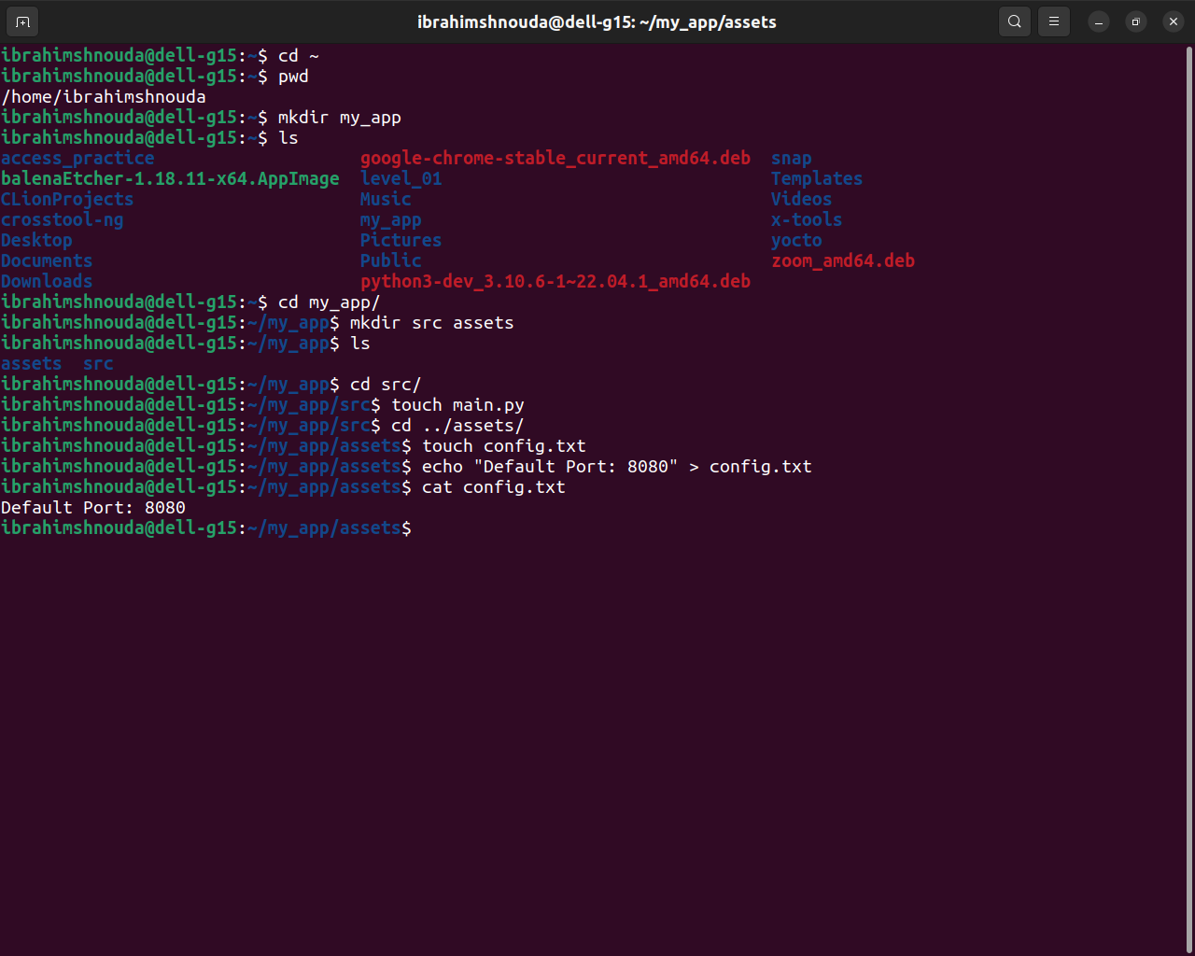

Part 2: Linking and Searching

1.Create a Symbolic Link:
1.1.
ibrahimshnouda@dell-g15:~/my_app$ ln -s assets/config.txt active_config

1.2.
ibrahimshnouda@dell-g15:~/my_app$ ls -l
total 8
lrwxrwxrwx 1 ibrahimshnouda ibrahimshnouda 17 Aug 27 15:11 active_config -> assets/config.txt
drwxrwxr-x 2 ibrahimshnouda ibrahimshnouda 4096 Aug 27 15:05 assets
drwxrwxr-x 2 ibrahimshnouda ibrahimshnouda 4096 Aug 27 15:05 src

2.Find System Files:
2.1.
ibrahimshnouda@dell-g15:~/my_app$ sudo find /etc -name services
[sudo] password for ibrahimshnouda:
/etc/avahi/services
/etc/services

2.2.
ibrahimshnouda@dell-g15:~/my_app$ sudo cp /etc/services ./assets/

3.Search File Content:
3.1.
ibrahimshnouda@dell-g15:~/my_app$ cat assets/services | grep "http"
# Updated from https://www.iana.org/assignments/service-names-port- numbers/service-names-port-numbers.xhtml .
http 80/tcp www # WorldWideWeb HTTP
https 443/tcp # http protocol over TLS/SSL
https 443/udp # HTTP/3
http-alt 8080/tcp webcache # WWW caching service

3.2.
ibrahimshnouda@dell-g15:~/my_app$ grep -n "http" assets/services
3:# Updated from https://www.iana.org/assignments/service-names-port- numbers/service-names-port-numbers.xhtml .
39:http 80/tcp www # WorldWideWeb HTTP
83:https 443/tcp # http protocol over TLS/SSL
84:https 443/udp # HTTP/3
263:http-alt 8080/tcp webcache # WWW caching service

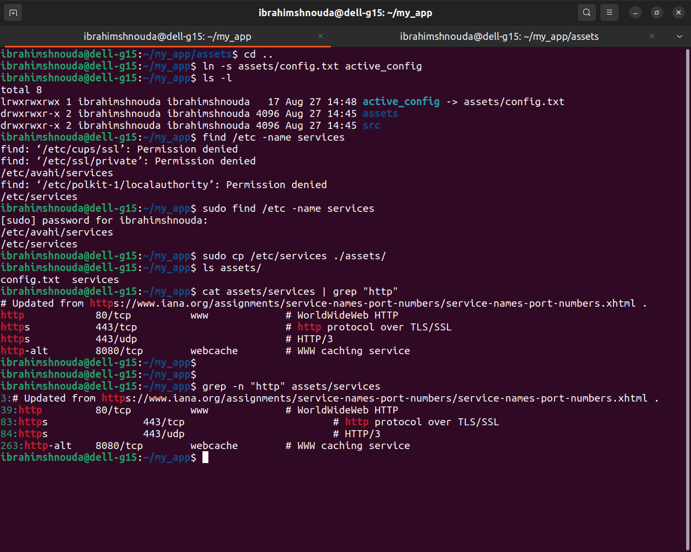
Part 3: Verification and Cleanup

1.Verify Directory Structure:
ibrahimshnouda@dell-g15:~/my_app$ tree
.
├── active_config -> assets/config.txt
├── assets
│ ├── config.txt
│ └── services
└── src
└── main.py

2 directories, 4 files

2.Clean Up:
2.1.
ibrahimshnouda@dell-g15:~/my_app$ rm active_config

2.2.
ibrahimshnouda@dell-g15:~$ rm -rf my_app

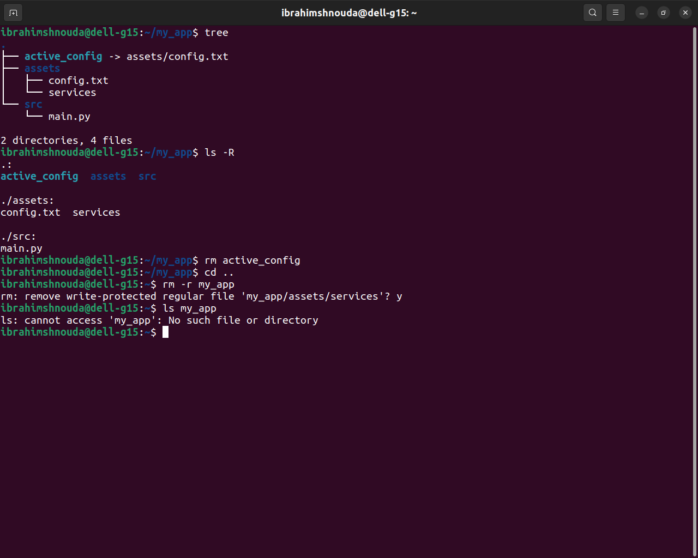

By: Ibrahim Shnouda
Thank you…

